**Nama :Izul Ikrom**

**TUGAS INSTALL**

Microsoft Windows [Version 10.0.19041.388]

(c) 2020 Microsoft Corporation. All rights reserved.

C:\Users\PC-07>cd sp5

C:\Users\PC-07\sp5>npx react-native init tugas

###### ######

### #### #### ###

## ### ### ##

## #### ##

## #### ##

## ## ## ##

## ### ### ##

## ######################## ##

###### ### ### ######

### ## ## ## ## ###

### ## ### #### ### ## ###

## #### ######## #### ##

## ### ########## ### ##

## #### ######## #### ##

### ## ### #### ### ## ###

### ## ## ## ## ###

###### ### ### ######

## ######################## ##

## ### ### ##

## ## ## ##

## #### ##

## #### ##

## ### ### ##

### #### #### ###

###### ######

Welcome to React Native!

Learn once, write anywhere

√ Downloading template

√ Copying template

√ Processing template

√ Installing dependencies

Run instructions for iOS:

• cd "C:\Users\PC-07\sp5\tugas" && npx react-native run-ios

- or -

• Open tugas\ios\tugas.xcodeproj in Xcode or run "xed -b ios"

• Hit the Run button

Run instructions for Android:

• Have an Android emulator running (quickest way to get started), or a device connected.

• cd "C:\Users\PC-07\sp5\tugas" && npx react-native run-android

Run instructions for Windows and macOS:

• See https://aka.ms/ReactNative for the latest up-to-date instructions.

C:\Users\PC-07\sp5>cd tugas

C:\Users\PC-07\sp5\tugas>code .

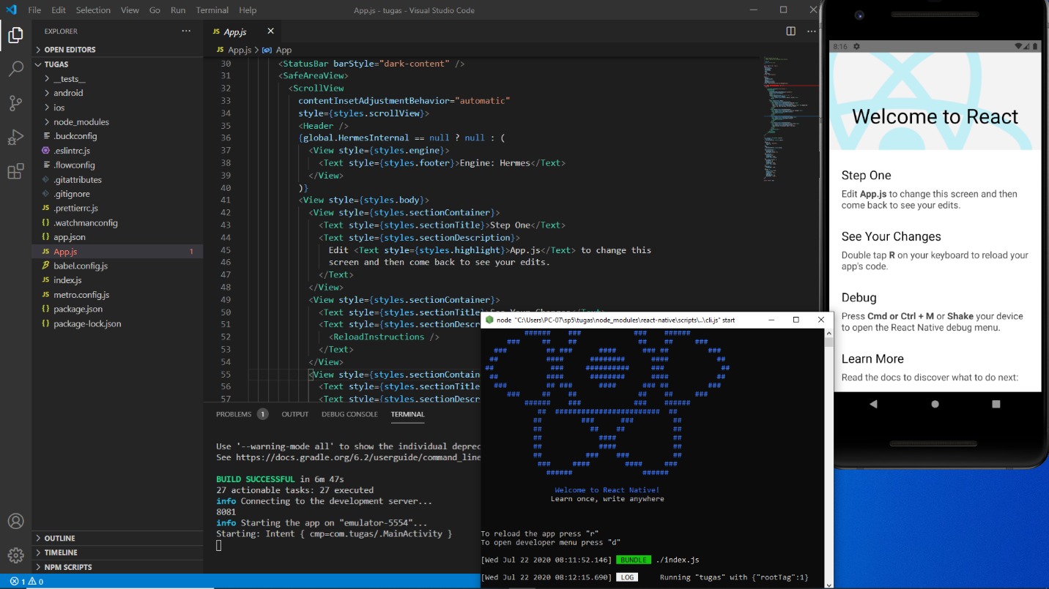C:\Users\PC-07\sp5\tugas>

**TUGAS 1**

import React, { useState } from 'react'

import {StyleSheet,Text,View, Button}from 'react-native';

export default function App(){

  return (

  <View style={styles.izul}>

    <Text>Perkenalkan Nama Saya :</Text>

      <Text style={styles.ikrom}>Izul Ikrom</Text>

  </View>

  );

}

const styles=StyleSheet.create({

  izul:{

    flex:1,

    backgroundColor:'lemonchiffon',

    alignItems:'center',

    justifyContent:'center'

  },

  ikrom:{

    marginTop:50,

    fontFamily:'ARCENA',

    fontSize:40,

  }

});

